**EXPERIMENT 10**

**AIM:** To study any one BI tool such as Pentaho, Tableau, and QlikView.

**THEORY:**

Business Intelligence (BI) tools are software applications that help businesses analyze and visualize their data to gain insights and make informed decisions. These tools can access data from various sources such as databases, spreadsheets, and other applications, and provide users with the ability to query, report, and visualize data in various formats.

BI tools are typically used by business analysts, data analysts, and other professionals who need to analyze and make sense of large amounts of data. They can be used to perform a wide range of tasks, including data analysis, reporting, visualization, performance monitoring, forecasting, budgeting, planning, and customer analytics.

Some popular BI tools include Tableau, Microsoft Power BI, QlikView, SAP BusinessObjects, and IBM Cognos Analytics. These tools have different features and capabilities, but all share a common goal of helping businesses turn raw data into actionable insights.

BI tools can help businesses improve their decision-making processes by providing them with accurate and up-to-date information. By analyzing data from various sources, businesses can identify trends, opportunities, and potential risks, and make informed decisions based on this information.

Some popular BI tools include:

* Tableau: a data visualization tool that allows users to create interactive dashboards, reports, and charts.
* Microsoft Power BI: a cloud-based BI platform that allows users to connect to various data sources, create reports and dashboards, and share insights with others.
* QlikView: a BI tool that allows users to build interactive dashboards, reports, and visualizations with its unique associative engine.
* SAP BusinessObjects: a suite of BI tools that allow users to create reports, perform ad-hoc queries, and analyze data from various sources.
* IBM Cognos Analytics: a BI tool that allows users to create reports and visualizations, and perform advanced analytics on data from various sources.

Comparing Business Intelligence tools like Pentaho, Tableau, and QlikView:

| Criteria | Tableau | Power BI | QlikView |
| --- | --- | --- | --- |
| Ease of Use | It offers a simple to use drag and drop interface. | Knowledge of Microsoft Excel and DAX is required for effective use. | Difficult to use without knowledge of Scripting and data models |
| BI Strength | It offers excellent visualization capability | It allows data manipulation prior to importing data. | The drill-down functionality that facilitates data discovery |
| Advanced Analytics Capabilities | Comes with certain features for advanced analytics and supports external integration | Predictive modeling and analytics are core competencies and integrate with R and Python. | It doesn’t offer any advanced analytics features and the scope of integrating it with external tools is quite limited. |
| Performance | Offers an easy-to-use mechanism and a user-friendly layout. | It allows users to generate advanced analytics along with visualizations. | In terms of BI, it is above Tableau but below Power BI and reverse in the case of visualizations. |
| Connectivity with Data | Tableau has its warehouse and employs cubing technique. | It requires no additional model and interacts with data directly | It does not require a data warehouse and uses the in-memory technique. |
| Options | Tableau offers multiple options, including Tableau Creator and Tableau Desktop. | Power BI offers just two options viz. Power BI Pro and Power BI Premium. | QlikView offers two options viz. Qlik Sense Business and Qlik Sense Enterprise along with more options in Integration and Developer. |
| Pricing | Multiple options in Tableau make pricing quite complex. | As compared to Tableau and QlikView, for Power BI, the pricing is low. | Pricing for some products is fixed while for others, it is variable. |
| Integration | It effectively integrates with external tools but not to the extent with Power BI does. | Power BI is superior in terms of integration. It integrates with different data sources of various types. | It doesn’t offer any strong functionality to integrate with an external tool. |
| Storage Limits | Cloud storage of a 100 GB limit is provided for workbooks and extracts. | A maximum cloud storage of 10 GB is allowed for all users. | The total cloud storage offered is 500 GB. The maximum app size is 250 MB |
| Suitability | It is best suitable for business users, researchers, and academics. | It is the best tool for dashboard development. | QlikView is excellent for in-house analytics teams. |
| Implementation | Tableau facilitates the easy and fast implementation with flexible options as compared to Power BI. | Power BI though offering an easy and quick implementation mechanism is available only as a SaaS model. | Implementation in the context of QlikView is quite slow as compared to Tableau and Power BI. |
| Positive Aspect | Tableau has a very high ranking in visualizations. | Power BI comparatively has a low price and offers scalability. | Being a relatively old BI tool, it has a well-developed community. |

**IMPLEMENTATION :**

**Load dataset in the tool**

1. Left hand section of Tableau home page, under connect section choose the option suitable to load your data set
2. For loading CSV file, click on “Text file”
3. Select the CSV from windows explorer
4. Dataset is loaded on tableau

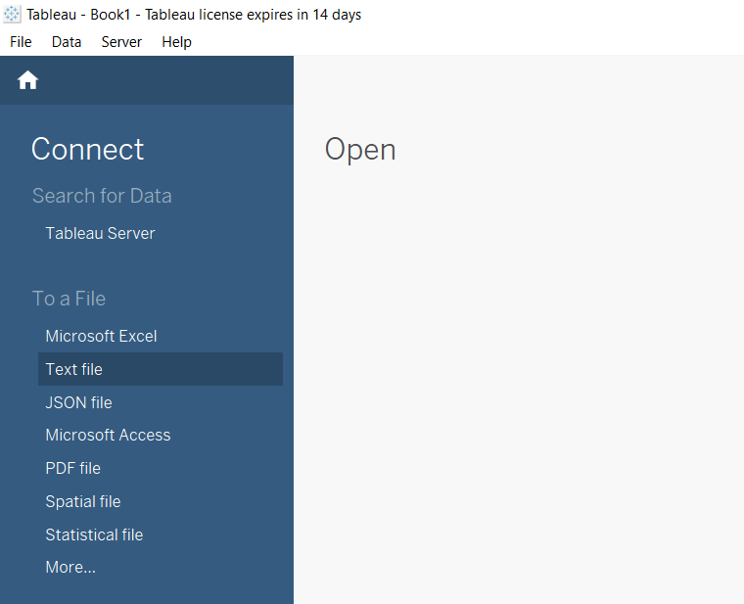

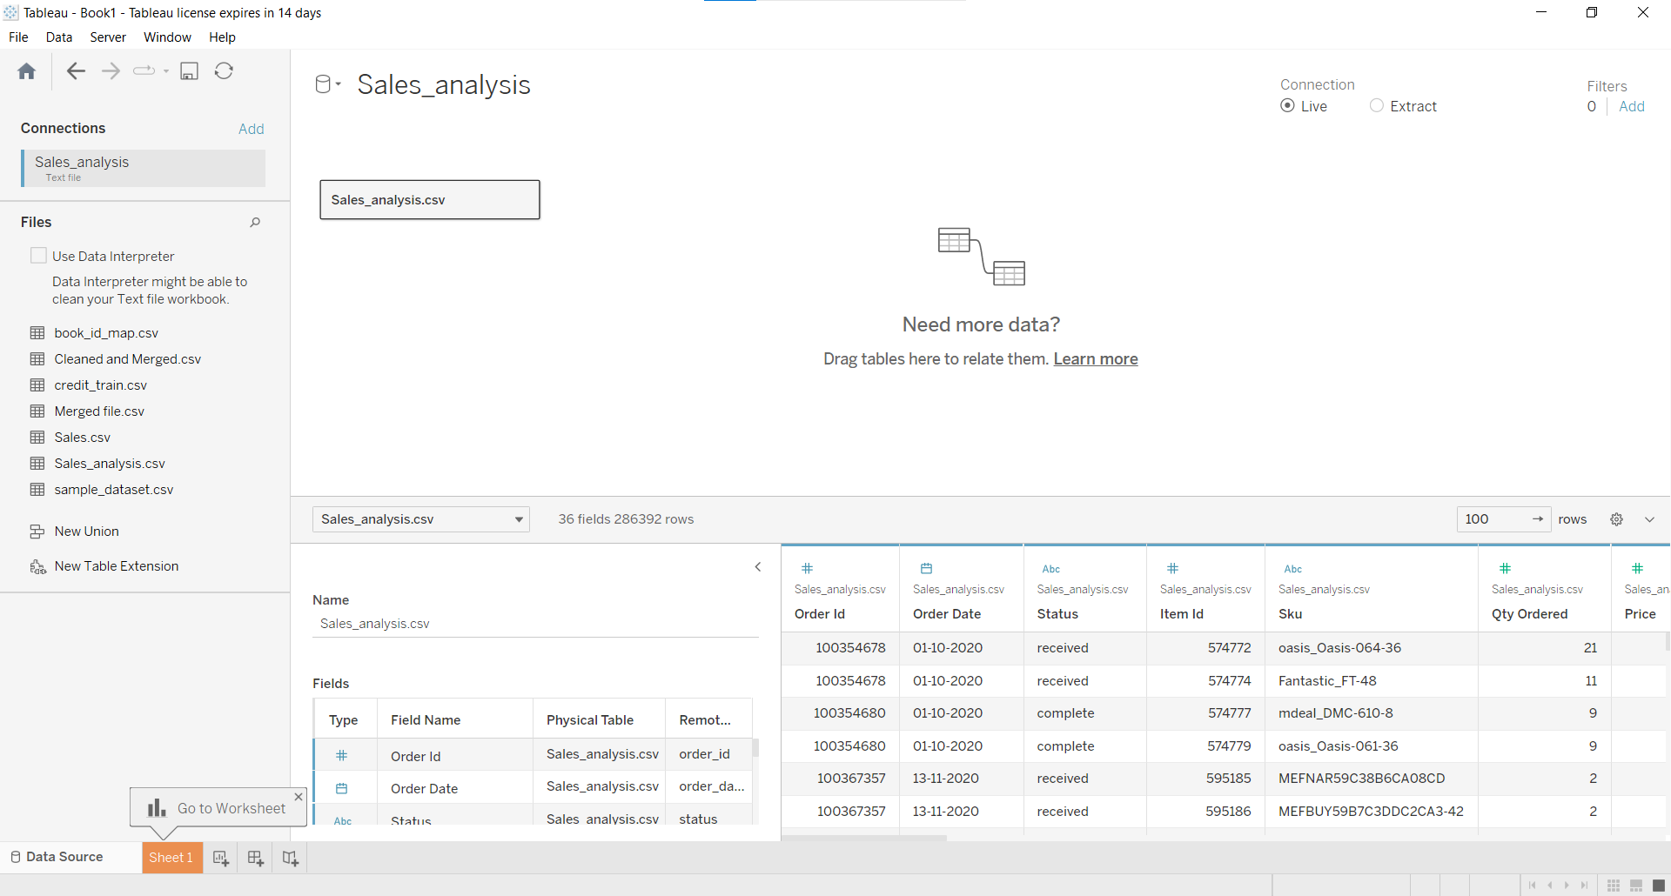

**Visualization**

1. Click on Sheet 1 at the bottom to open the visualization window.

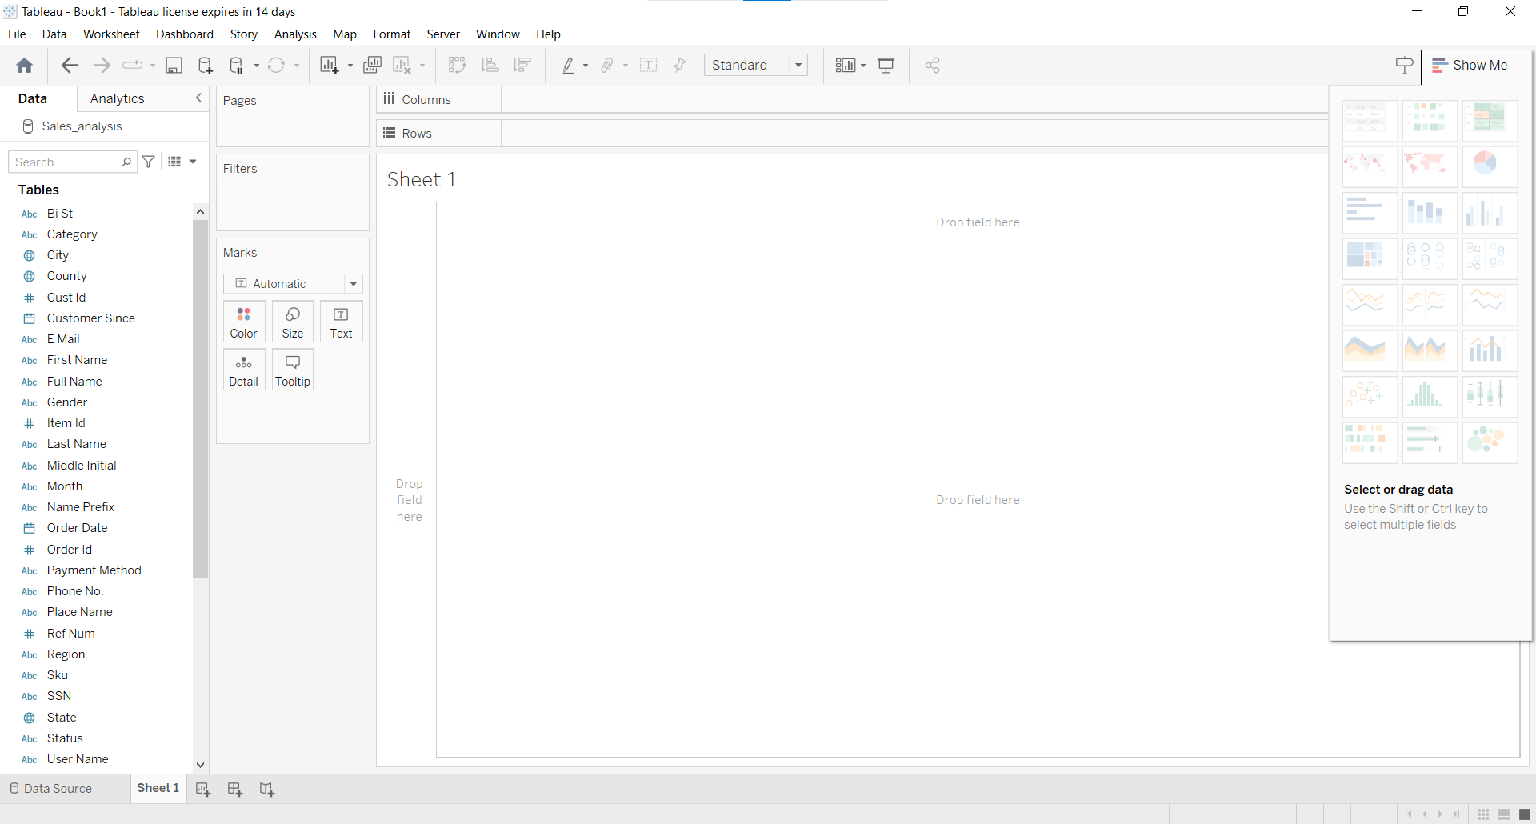

2. Draw a line plot of revenue per month by selecting total as a row and month as a column.

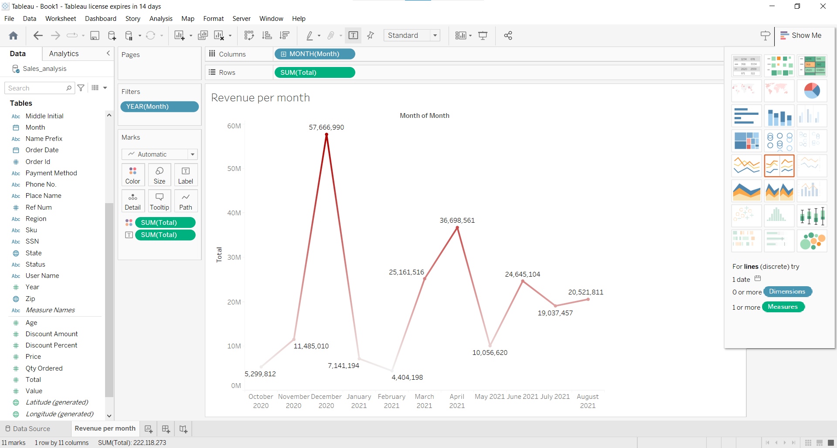

3. Draw a bar graph of revenue based on age by considering the total as a row and age as a column.

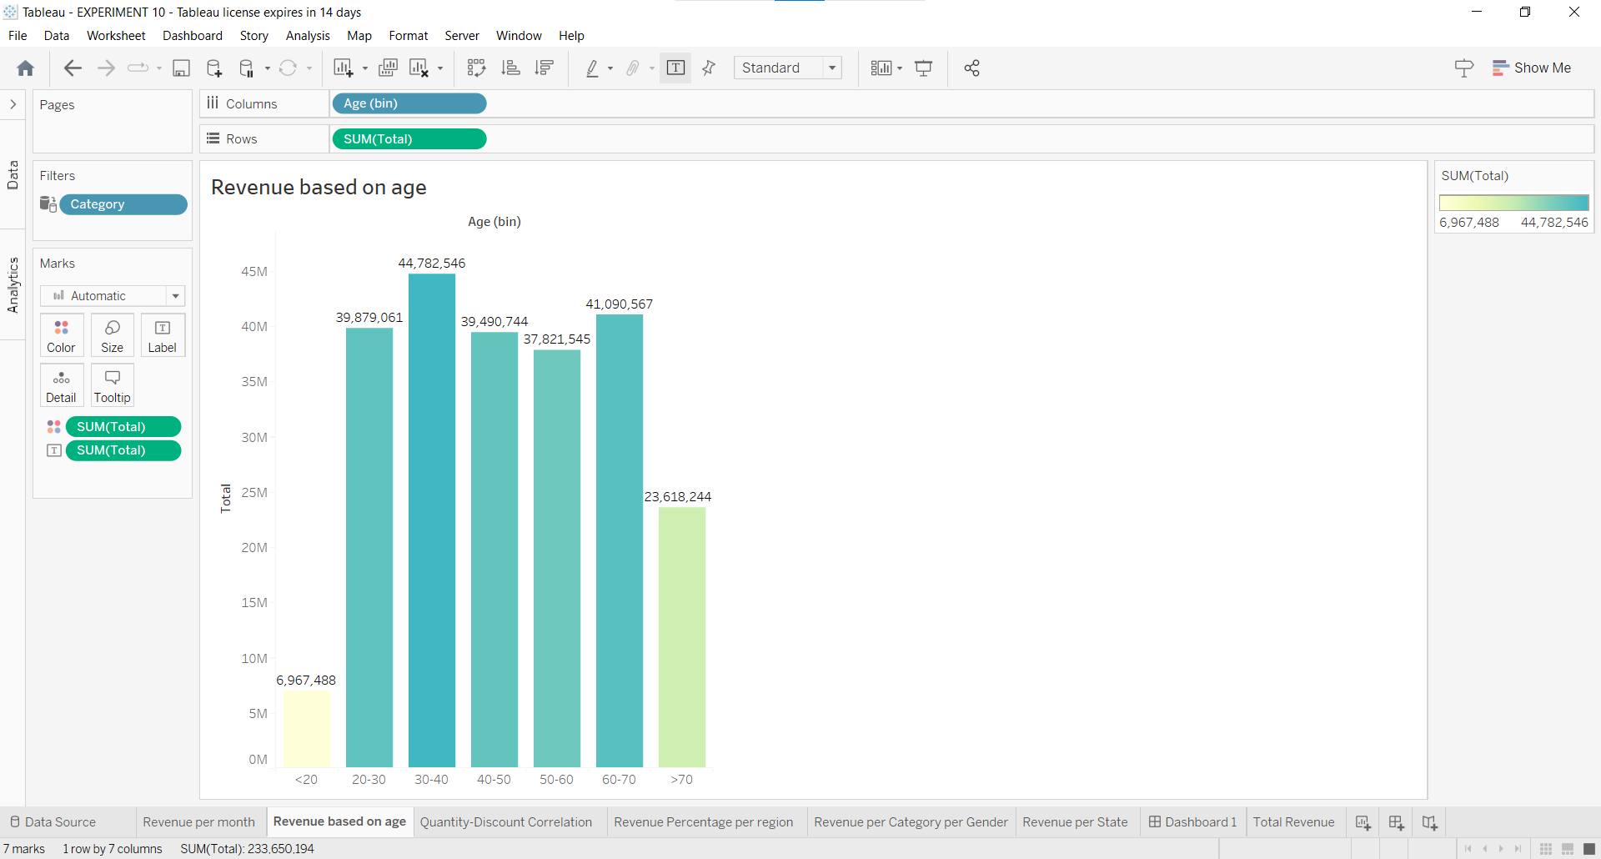

4. Draw a correlation diagram of quantity vs discount by selecting quantity as a row and Discount as a column.

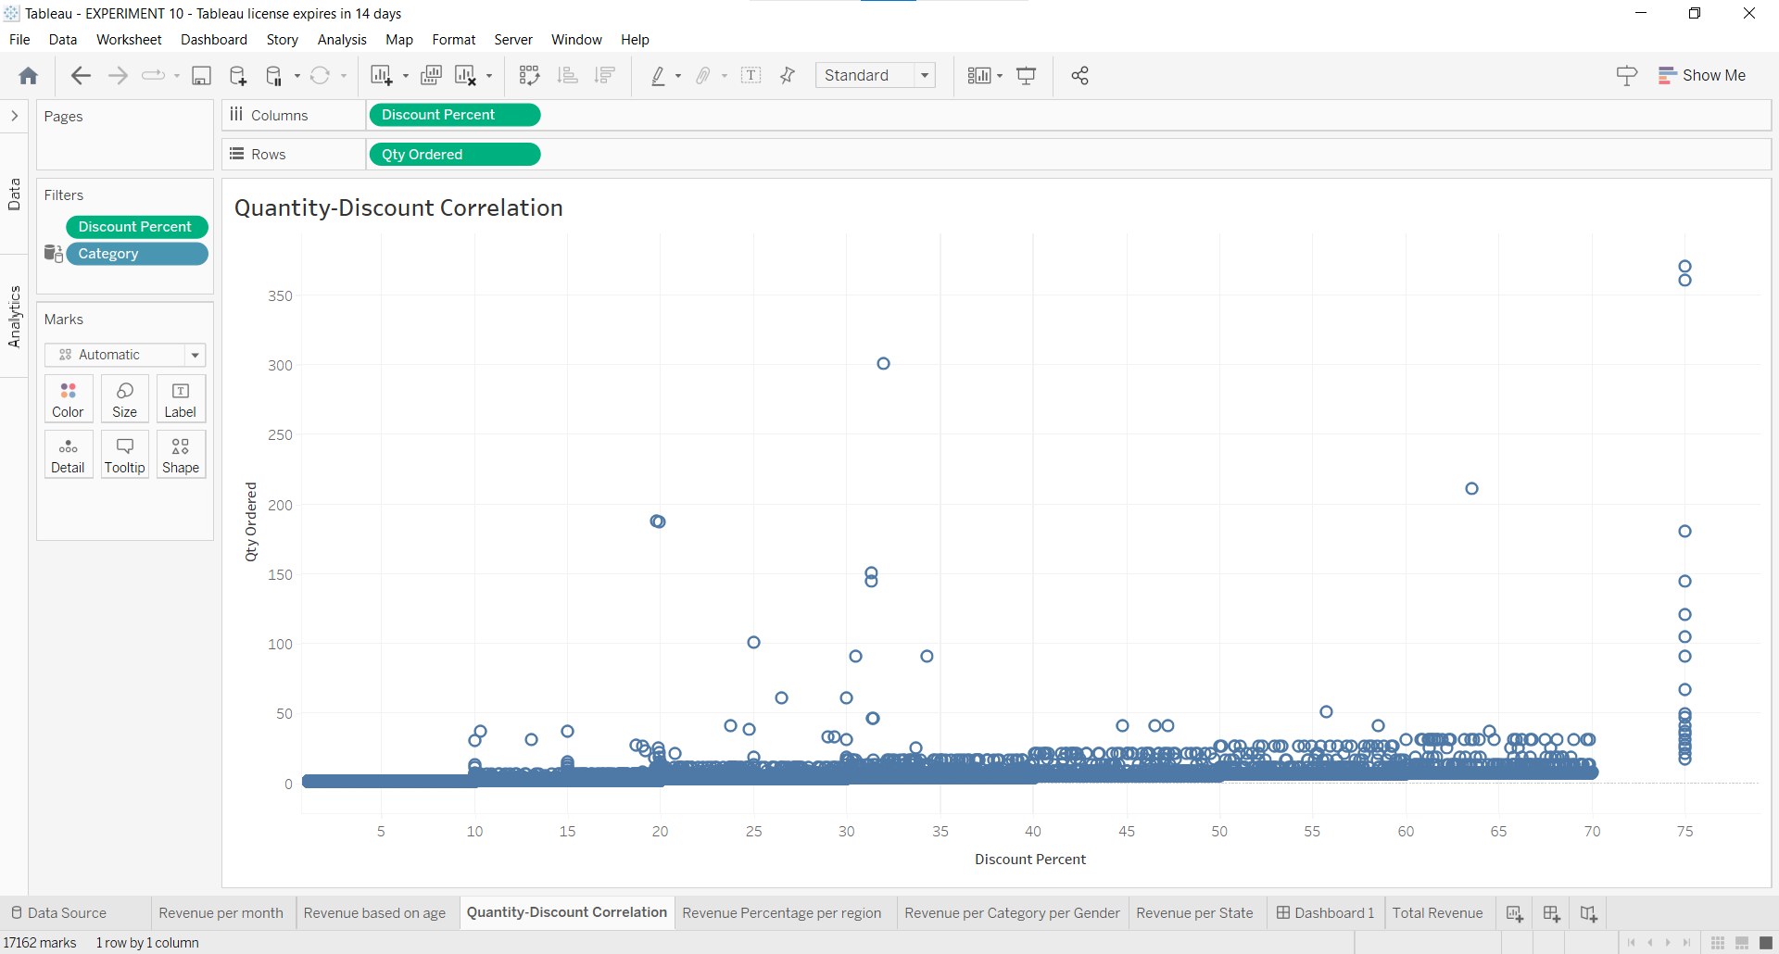

5. Draw a pie chart of revenue percentage per region by using the zero axis.

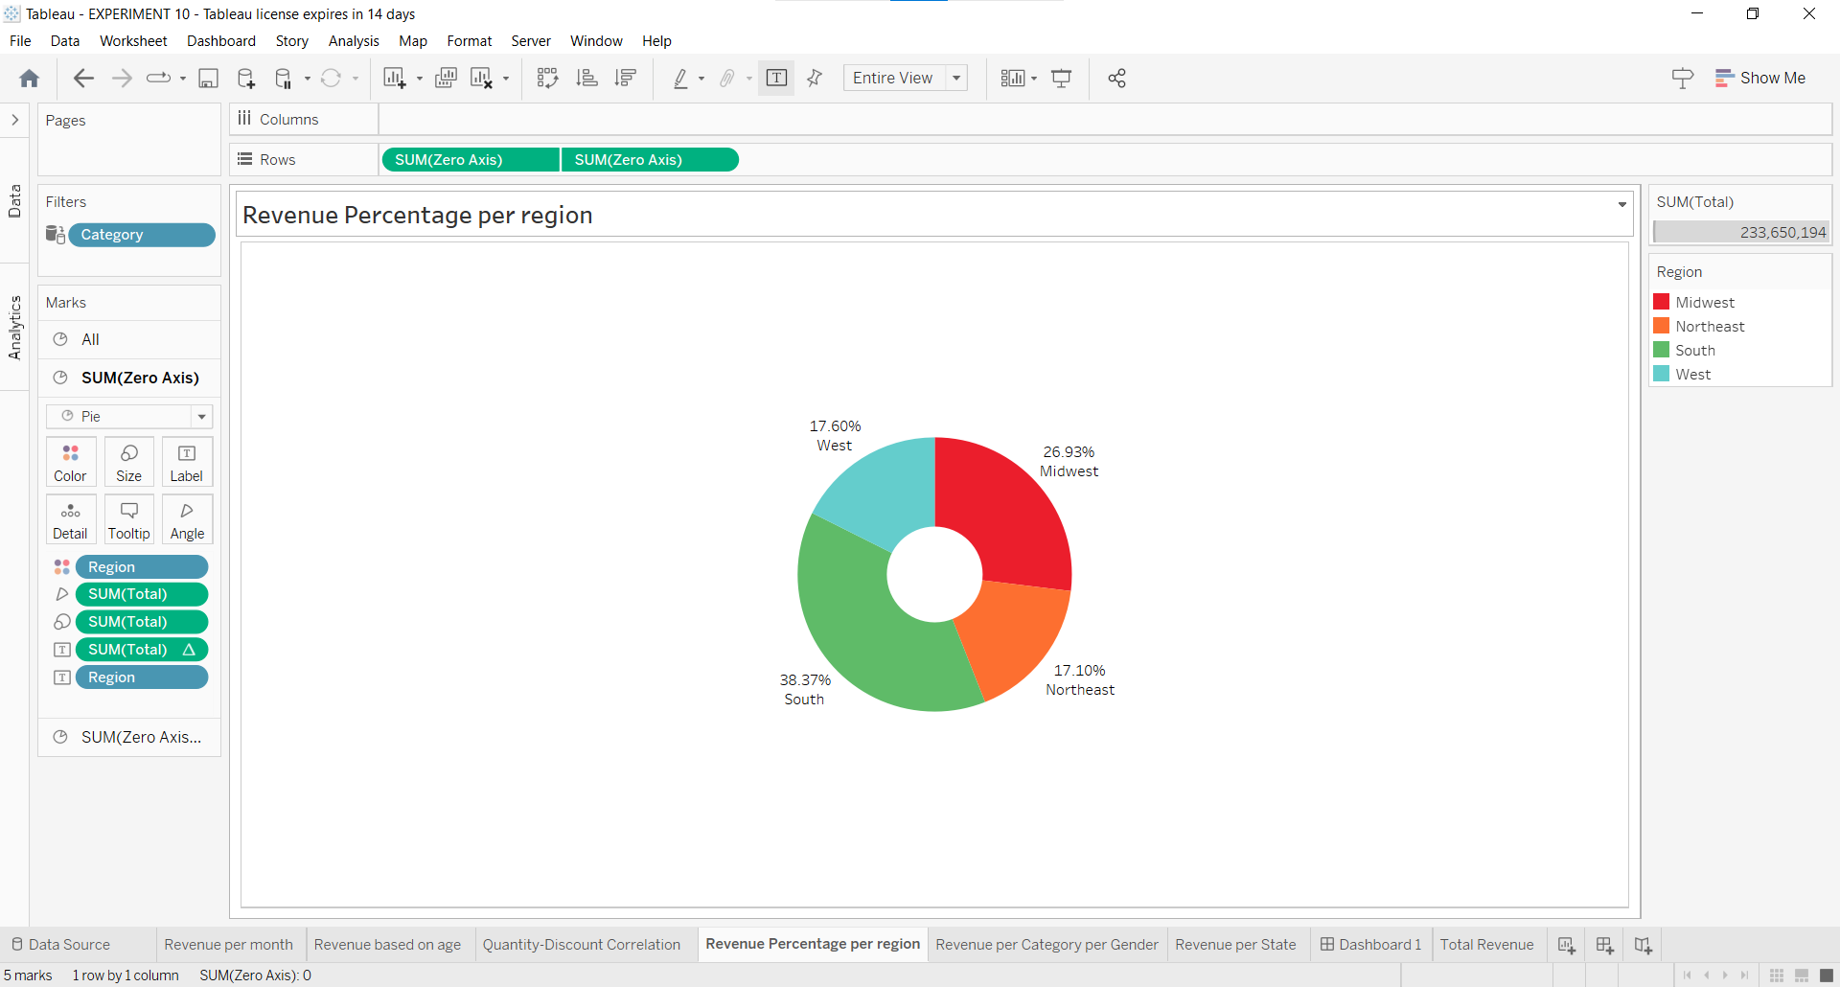

6. Draw a butterfly plot of revenue per category per gender

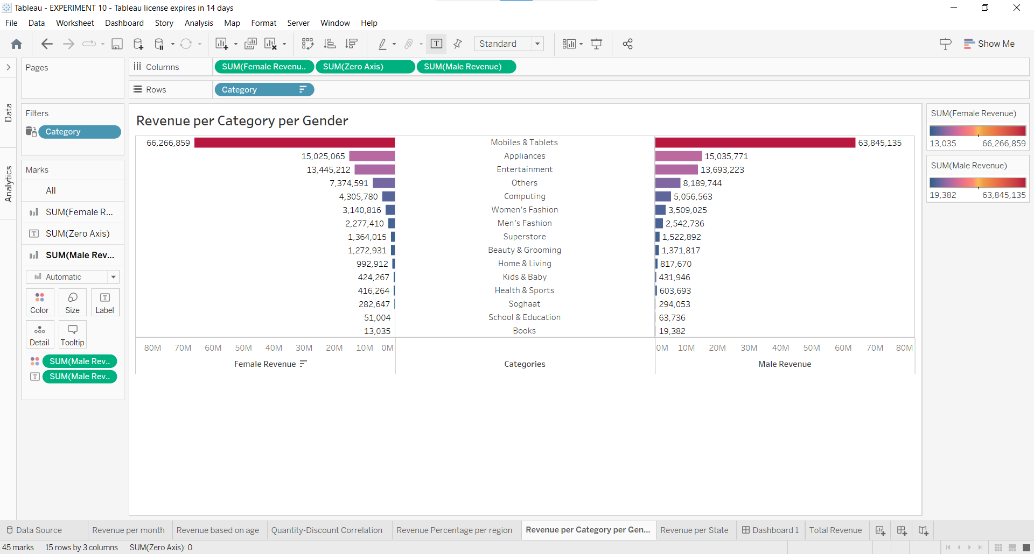

7. Draw a map of revenue per state.

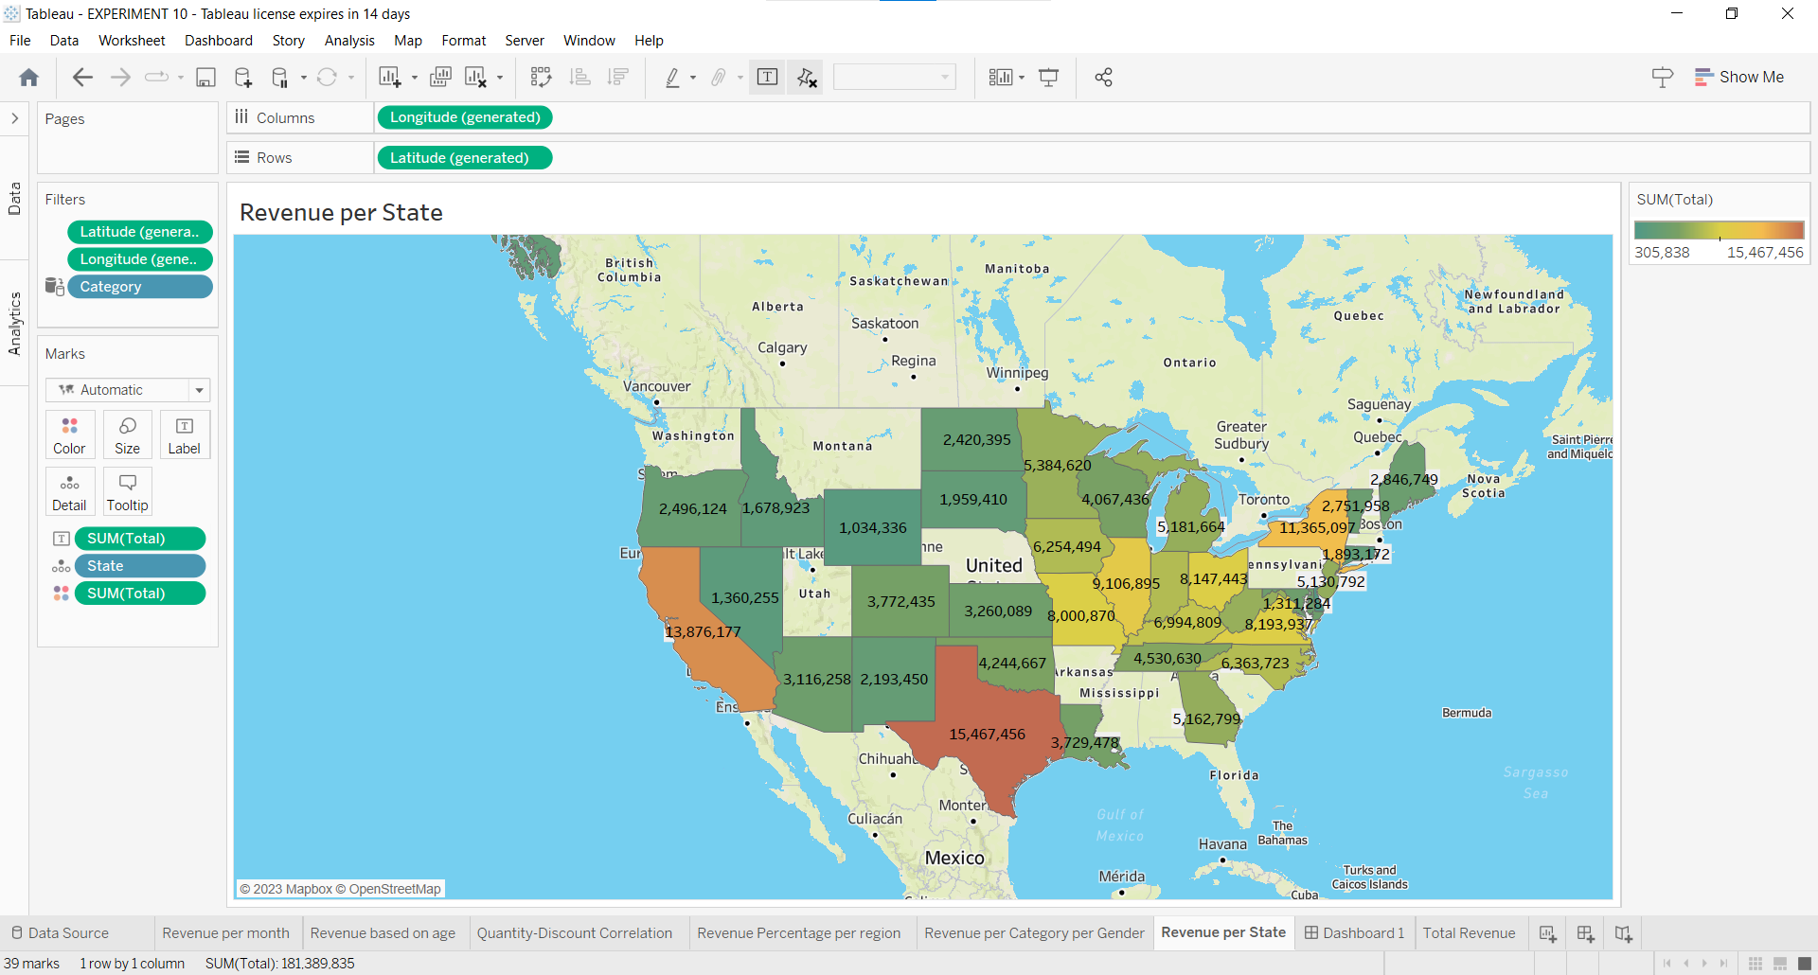

8. Create a new dashboard and drag and drop all the sheets created above. Then create a drop-down to select the category and a text field that displays the total revenue.

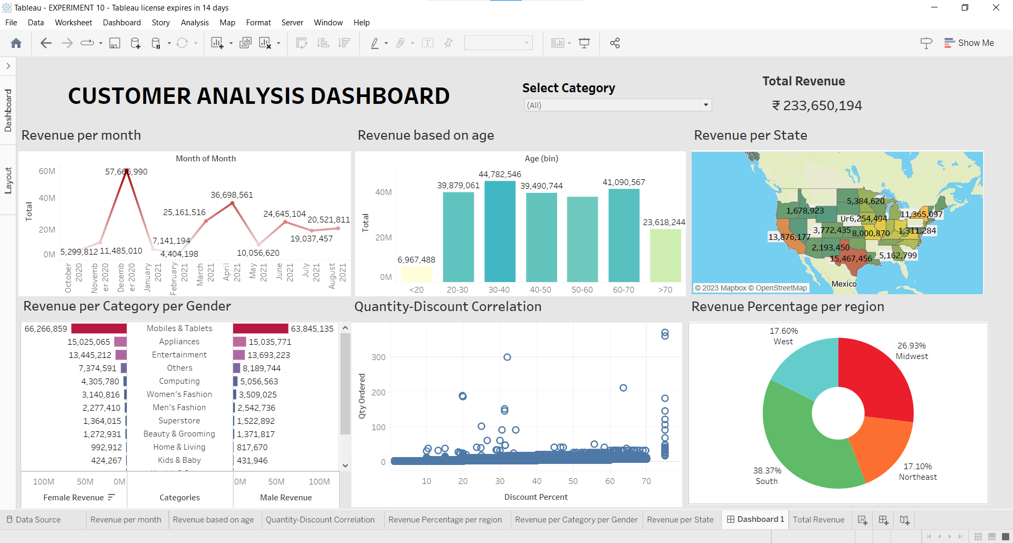

The dashboard for Customer analysis is ready.

**CONCLUSION:**

In this experiment, we have compared Business Intelligence tools like Pentaho, Tableau, and QlikView.Later, we created a customer analysis dashboard using Tableau and created a report.